

**CAPSTONE PROJECT 1**

**PROPOSAL DOCUMENT**

**ENGLISH FOR YOU**

Version 1.0

Date: Aug 28, 2018

**TEAM**: **Fantastic 4**

**MENTOR:** Truong Tien Vu

**MEMBER**: Tran Nguyen Huu Nghia

Do Van Truong

Doan Nu Thuc Oanh

Dinh Tran Anh Truc

**INTERNATIONAL SCHOOL**

**Project Information**

|  |  |  |  |  |  |
| --- | --- | --- | --- | --- | --- |
| **Project acronym** | Eng4you | | | | |
| **Project Tittle** | [E4U] English For You | | | | |
| **Start Date** | Aug 15, 2018 | | **End Date** | | Dec 5, 2018 |
| **Lead Institution** | International School, Duy Tan University | | | | |
| **Project Mentor & contact details** | Mr. Vu Truong Tien  Email: vudalat@yahoo.com  Tel: 0914083188 | | | | |
| **Scrum Master & contact details** | Nghia ,Tran Nguyen Huu  Email: trannguyenhuunghia97@gmail.com  Tel: 0934848229 | | | | |
| **Team members** | **Name** | **Email** | | **Tel** | |
| Truong, Do Van | [Truongdtct1230@gmail.com](mailto:Truongdtct1230@gmail.com) | | 01674275453 | |
| Oanh, Doan Nu Thuc | [Doannuthucoanh0410@gmail.com](mailto:Doannuthucoanh0410@gmail.com) | | 01674552075 | |
| Truc, Dinh Tran Anh | [Anhtruc2091997@gmail.com](mailto:Anhtruc2091997@gmail.com) | | 0947360347 | |

**Proposal Document**

|  |  |  |  |
| --- | --- | --- | --- |
| **Document Title** | Proposal Document |  |  |
| **Reporting Period** | Sep 4, 2018 |  |  |
| **Author(s) &**  **project** | Nghia ,Tran Nguyen Huu  Scrum Master | |  |
| **Team Information** | **Name** | **Role** |  |
| Truong, Do Van | Member |  |
| Oanh, Doan Nu Thuc | Member |  |
| Truc, Dinh Tran Anh | Member |  |
| **Date** | 28 Aug, 2018 | **Filename** | Proposal_Ver1.0.docx |
| **Access** | Project and CMU Program | |  |

|  |  |  |
| --- | --- | --- |
| Document History | | |
| **Version** | **Date** | **Comments** |
| V1.0 | 28-Aug-2018 |  |

**Document Approvals**

The following signatures are required for approval of this document.

|  |  |  |
| --- | --- | --- |
| Mr. Vu Truong Tien  *Mentor & Product Owner* |  | Date: Aug 29, 2018 |

Table of Contents

1. Introduction 1

1.1 Purpose 1

1.2 Scope 1

1.3 References 1

2. Product Overview 2

2.1 Project definition 2

2.2 Business Need 2

2.3 Prior Art 2

2.4 Proposed Solution 3

2.4.1 Project goal 3

2.4.2 System Overview 3

2.4.3 Technical Constrains 5

3. Master Plan 6

3.1 Scrum Process 6

3.2 Master Plan 7

3.3 Organization Management 8

3.3.1 Human Resource 8

3.3.2 Cost Estimate 8

***3.*3.2.2. Total Cost Estimate** 8

# Introduction

## 1.1 Purpose

The purpose of the Proposal document is to:

* Define the business need and problems in detail.
* Provide solutions for business needs and show the overview of system context and architecture.
* Provide overview about resources, schedule, solution and budget for the project.

## 1.2 Scope

This document provides an overview of project will be developed. It includes the description of business need, the proposed solution, financial forecast and some constraints that involved in the project.

The document provides a comprehensive master plan for each phase of software development based on the processes that have been selected.

This document is made for senior management to put forward a proposal.

## References

|  |  |  |
| --- | --- | --- |
| **No.** | **References** | **Document Information** |
| 1 | **Scrum** **process** | [www.scrum.org](http://www.scrum.org) |
| 2 | **Games as a tool for teaching English vocabulary to young learners** | http://www.worldscientificnews.com |

# Product Overview

## Project definition

Developed Eng4you website is a website that help user learning English through game. Two people in one team co-operate with each other to explain words, User can listen music and write sentences in that song, and user can chat with foreign to raise their English skill

## Business Need

***Business Problems:***

* English nowadays become second language
* Borings when learning English alone
* Lack of confidence in communication
* Need to much time to translate from native language to English

***Business Need:***

* Take initiative time to learning ( learning whenever they want)
* Communication with foreign to raise English skill
* Didn’t afraid when wrong
* An website can learning English and entertainment
* Interactive, co-operate with other people to learning English

## Prior Art

Up till now, there are many Website about learning English like (<https://elight.edu.vn> , <https://x3english.com> ) but our website has the function of cooperating among players to explain vocabulary.

This function make players always brainstorming use ability English of themselves to explain words to they teammate, create an interest in the learning.

.

## Proposed Solution

English for you [E4U] website can help user who want learning English, easily and more interested in learning English through co-operate, communicate with each other to solve problems

### Project goal

The goal of project is to build the English for you [E4U] website with four main functions

1. **Game words explain**: The website will auto matching two people in one team in order to explain words and another will guess what that word is.
2. **Game Listen**: The website will choose a little piece of a random song for user hear and correct lyric of that song.
3. **Chat with foreign**: The website will list the users are online and user can choose the one you want to chat to.
4. **Translate**: The website can help user translate when user click right mouse on that word.

### System Overview

#### Achitecture overview

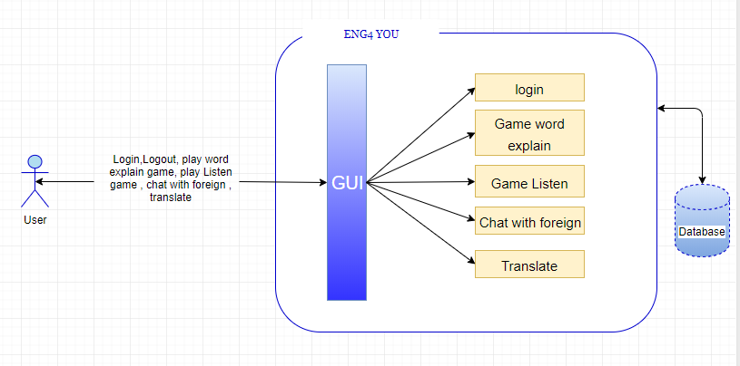

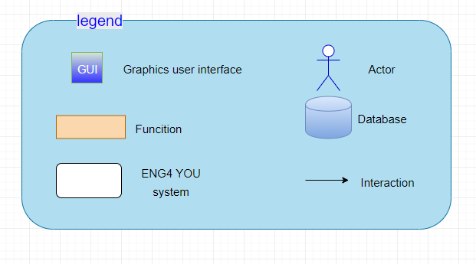

***Figure 1: Achitecture Overview***

#### 2.4.4.2 Achitecture description

* **Users**
* Users can registration , login , logout in system,
* Users choose word explain game to play
* Users choose Listen game to play
* Users can translates word
* Users can chat with foreign

### Technical Constrains

**Technical to develop**

* Language: PHP, HTML, CSS , JavaScript , JQuery
* Framework: Laravel
  + - Web Server: Apache.
    - Development tool : Sublime text , Dreamweaver CS6
    - Database Management System: MySQL

**Environment**

* Web browsers: Internet Explorer, Mozilla Firefox, Apple Safari, Google Chrome, and so on.
* Operation systems: Microsoft Windows, Linux, and Apple Mac OS.

**Other Constraints**

* Resource: 4 people.
* Budget: Limited.
* Time: The project must be completed within 04 months.
* Area: Danang city.

# Master Plan

## 3.1 Scrum Process

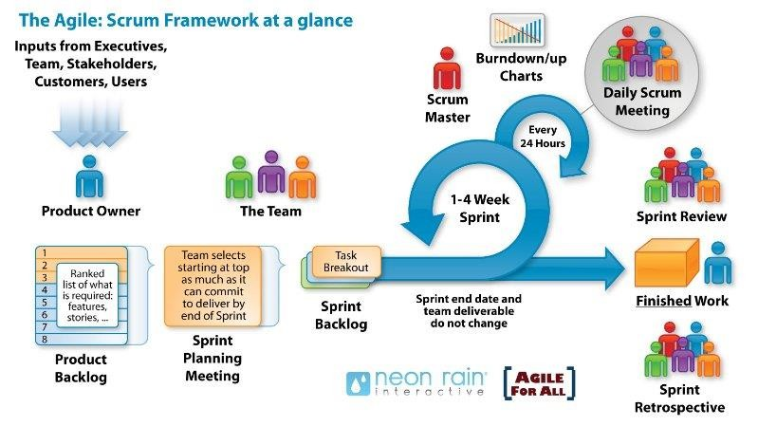

***Figure 3: General SCRUM Process***

* Scrum is an iterative and incremental agile software development framework for managing software projects and product or application development.
* Scrum focuses on project management institutions where it is difficult to plan ahead.
* Mechanisms of empirical process control, where feedback loops that constitute the core management technique are used as opposed to traditional command-and-control management.
* Its approach to planning and managing projects is by bringing decision-making authority to the level of operation properties and certainties.
* Benefit of the methodology:
  + - Project can respond easily to change.
    - Problems are identified early.
    - Customer gets most beneficial work first.
    - Work done will better meet the customer’s needs.
    - Improved productivity.
    - Ability to maintain a predictable schedule for delivery.

## 3.2 Master Plan

|  |  |  |  |  |
| --- | --- | --- | --- | --- |
| **NO** | **Task Name** | **Duration** | **Start** | **Finish** |
| **1.** | **Initial** | **19 days** | **15 – Aug – 2018** | **03 –Sep– 2018** |
| 1.1 | Gathering Requirement | 9 days | 15 – Aug – 2018 | 24 – Aug – 2018 |
| 1.2 | Create Proposal Document | 10 days | 28 – Aug – 2018 | 03 – Sep – 2018 |
| **2** | **Start Up** | **16 days** | **05 – Sep** **– 2018** | **21 – Sep** **– 2018** |
| 2.1 | Project Kick-off Meeting | 2 day | 05 – Sep – 2018 | 07– Sep – 2018 |
| 2.2 | Create Document | 14 days | 08 – Sep – 2018 | 21 – Sep – 2018 |
| **3** | **Development** | **67 days** | **21 – Sep** **– 2018** | **26– Nov – 2018** |
| 3.1 | Sprint 1 | 21 days | 21 – Sep – 2018 | 11 – Oct – 2018 |
| 3.2 | Sprint 2 | 22 days | 12 – Oct – 2018 | 3 – Nov – 2018 |
| 3.3 | Sprint 3 | 23 days | 4 – Nov – 2018 | 26 – Nov – 2018 |
| **4** | **Project’s Retrospective Meeting** | **01 day** | **27 – Nov – 2018** | **28 –Nov– 2018** |
| **5** | **Final Release** | **02 day** | **03 – Dec – 2018** | **05 – Dec – 2018** |

## 3.3 Organization Management

### 3.3.1 Human Resource

|  |  |  |  |
| --- | --- | --- | --- |
| **Full Name** | **Phone** | **Email** | **Position** |
| Mr. Vu Truong Tien | 0914083188 | vudalat@yahoo.com | Mentor |
| Nghia ,Tran Nguyen Huu | 0934848229 | trannguyenhuunghia97@gmail.com | Scrum Master |
| Truong, Do Van | 01674275453 | [Truongdtct1230@gmail.com](mailto:Truongdtct1230@gmail.com) | Member |
| Oanh, Doan Nu Thuc | 01674552075 | [Doannuthucoanh0410@gmail.com](mailto:Doannuthucoanh0410@gmail.com) | Member |
| Truc, Dinh Tran Anh | 0947360347 | [Anhtruc2091997@gmail.com](mailto:Anhtruc2091997@gmail.com) | Member |

### 3.3.2 Cost Estimate

***3.3.2.1.*** **Cost Person/Hours**

|  |  |  |
| --- | --- | --- |
| **Full Name** | **Role** | **Salary Rate (USD/hour)** |
| Nghia ,Tran Nguyen Huu | Scrum Master | 1 |
| Truong, Do Van | Team Member | 1 |
| Oanh, Doan Nu Thuc | Team Member | 1 |
| Truc, Dinh Tran Anh | Team Member | 1 |

***3.*3.2.2. Total Cost Estimate**

|  |  |  |  |
| --- | --- | --- | --- |
| **No** | **Criteria** | **Price** | **Total (USD)** |
| 1 | Working hours |  |  |
| 4 | PC’s depreciation |  |  |
| **Total cost** | | |  |

|  |  |  |
| --- | --- | --- |
| **Description** | **Amount** | **Unit** |
| Number of members | 4 | Person |
| Number of working hour per day | 2 | Hours |
| The cost per hour per member | 1 | USD |
| The duration of the project | 3 | Months |
| Price of each computer | 600 | USD |
| The lifelong of each computer | 5 | Years |
| The time to use of each computer | 3 | Months |
| The number of working days | 110 | Days |

**- Explain:**

* + - PC's depreciation = 600/(12*5)*3 =30
    - Amount of working hours = 4 members * 2 hours * 110 days.